**Cryptocurrency Derivatives**

**A PROJECT REPORT FOR**

**FRE 6073 – Introduction to Derivatives**



**Submitted By Zeyu Yue**

**Cryptocurrency Derivatives**

I. Abstract

Blockchain, the powerhouse that led to the existence of cryptocurrencies such as bitcoin, Ethereum and others, introduced to public trading platforms that facilitate trustless, efficient, secure, and transparent transactions. With more investors owning these digital coins as investment tools, cryptocurrency derivatives – hedging instruments with cryptocurrency as underlying assets – while nascent, has become a booming market and has attracted investors and researchers to explore and benefit from these instruments. This paper provides a general study on crypto derivatives via introducing the mechanics of blockchain, the development of the cryptocurrency market, trading mechanics on crypto exchanges, and typical types of crypto derivatives with emphasis on crypto futures and options. Since cryptocurrencies exist without central authorities, the price movements are strongly affected by market sentiments and undergo intense volatility. The valuation of crypto derivatives in turn requires different assumptions. The paper then provides examples and techniques of deriving the fair values.

Finally, an introduction to other crypto instruments including crypto bonds, swaps, loans is given.

Example of Key Words: Cryptocurrency, Bitcoin, Ethereum, crypto futures, perpetual futures, crypto options, Smart Contracts, CBDCs.

II. Introduction

1. Cryptocurrencies: Bitcoin/Ethereum

• What are Bitcoin/Ethereum?

Bitcoin is a decentralized virtual currency that uses peer-to-peer technology to operate without the need for third-party involvement in financial transactions[1]. It is secured and verified using cryptography, and its transactions are stored on computers distributed all over the world via blockchain technology. Bitcoin is considered a store of value like gold and has inspired the development of many other cryptocurrencies that either attempt to replace it as a payment system or are used as utility or security tokens in other blockchains and emerging financial technologies. Ethereum, launched in 2015, builds on Bitcoin's innovation with some significant differences. It is programmable, allowing for the creation and deployment of decentralized applications on its network, enabling great innovation.

Ethereum is considered a marketplace of financial services, games, social networks, and other apps that respect user privacy and cannot be censored[2]. It is designed to be scalable, programmable, secure, and decentralized and is the blockchain of choice for developers and enterprises creating technology to change how industries operate[3]. Ethereum's native token is ether, and it can be used to pay for work done supporting the blockchain or tangible goods and services if accepted.

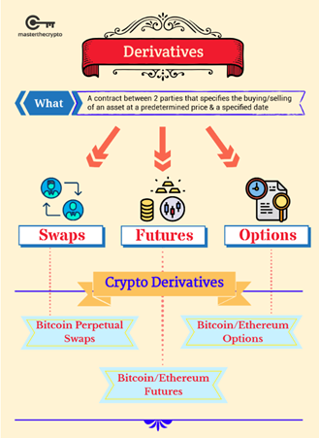

source:masterthecrypto.com

• Who are the primary users?

Yelowitz and Wilson identified four types of broad bitcoin users: computer programming enthusiasts, speculative investors, libertarians, and criminals[4]. Libertarians value the perceived lack of regulation, while speculators focus on bitcoin's potential as an investment. Computer programming enthusiasts are interested in blockchain technology, while criminals value the perceived anonymity of bitcoin. Despite assumptions that bitcoin users are oddballs, fantasists, nerds, or criminals, the reality is more complex. Overall, the diverse range of bitcoin users and their varying perspectives on the technology's development highlight the challenges of creating a consensus in the bitcoin community.

• What are typical uses for Bitcoin/Ethereum?

Bitcoin is primarily used as a store of value and a means of payment that allows for fast and low-cost transfers of value across borders[5]. Additionally, some people invest in Bitcoin as a speculative asset, as its price has been known to fluctuate widely[6]. Ethereum, on the other hand, is a platform for decentralized applications (dApps) that can be used for a variety of purposes, such as decentralized finance (DeFi) applications where users can earn interest on their cryptocurrency holdings or lend and borrow funds. It also allows for the creation of smart contracts, which are self-executing contracts that can automate the transfer of assets or the performance of tasks based on predetermined conditions. Ethereum's typical uses are broader and more diverse than Bitcoin's, with applications including non-fungible tokens (NFTs) for digital art and collectibles. Overall, both Bitcoin and Ethereum have unique features that allow for exciting uses not covered by previous payment systems.

• What are the primary benefits to using Bitcoin/Ethereum? Primary concerns?

For Bitcoin, we can benefit from its decentralization, transparency, security, low transaction fees and global accessibility[7]; However, for Ethereum, we can benefit from its programmability, flexibility, speed, security and decentralization[8].

The primary concerns associated with using Bitcoin and Ethereum include:

1. Regulatory uncertainty: The regulatory landscape surrounding cryptocurrencies is constantly evolving, leading to uncertainty for users and developers.
2. Security risks: Despite their inherent security features, Bitcoin and Ethereum are still vulnerable to hacks and other security risks.
3. Volatility: The value of cryptocurrencies can be highly volatile, leading to uncertainty for investors.
4. Scalability: As cryptocurrencies become more popular, concerns have been raised about their ability to scale to accommodate increased demand.
5. Energy consumption: The process of mining cryptocurrencies can be highly energy-intensive, leading to concerns about their environmental impact.

• What are coins and tokens?

Coins and tokens are both types of digital assets that operate on blockchain technology. Coins are typically native to a specific blockchain and are used as a medium of exchange or store of value[9]. Bitcoin, for example, is a coin that operates on its own blockchain. Tokens, on the other hand, are created and operate on top of an existing blockchain. They are often used to represent assets or utility and can be traded or exchanged like coins. Tokens can be created on various blockchain platforms, such as Ethereum, and can be used to represent anything from loyalty points to real estate assets. Both coins and tokens can be bought and sold on various cryptocurrency exchanges.

• How do types of crypto exchanges differ from one another?

There are several types of cryptocurrency exchanges, each with its own unique features and characteristics[10].

1. Centralized exchanges (CEX) are the most common type of exchange and operate like traditional stock exchanges. They have a centralized authority that manages the exchange and handles all transactions. They often have higher trading volumes and liquidity but may require users to provide personal information and undergo a verification process.
2. Decentralized exchanges (DEX) operate on a decentralized blockchain network and do not have a central authority. They allow for peer-to-peer trading and offer greater privacy and security but may have lower trading volumes and limited liquidity.
3. Hybrids exchanges are known to be the next generation crypto trading marketplace. They take the advantage of CEX ‘s functionality and liquidity and DEX’s privacy and security. The first ever hybrid exchange was Qurrex, which launched in 2018.

• How do Crypto wallets work?

A cryptocurrency wallet is a software program that stores public and private keys used to send and receive digital currency[11]. When one user sends another user digital currency, they are essentially transferring ownership of the coins to your wallet's address. To spend those coins and access the funds, the private key stored in your wallet must match the public address the currency is assigned to. There are different types of crypto wallets, including desktop, mobile, hardware, and web wallets. Security is crucial when using a crypto wallet, and users must keep their private keys safe and not share them with anyone. Additional security features like two-factor authentication and multi-signature support are also available in many wallets.

• How are cryptos created?

Cryptocurrencies are created through a process called mining, which involves solving complex mathematical equations to verify and record transactions on a blockchain network[12]. Miners compete with each other to solve these equations and are rewarded with newly created digital coins as well as transaction fees. The process of mining is designed to be difficult and resource-intensive to prevent fraud and ensure the security of the network.

However, not all cryptocurrencies are created through mining[12]. Some are pre-mined, where a certain number of coins are created and distributed to the creators and early investors before the currency is released to the public. Others are created through initial coin offerings (ICOs), where a new cryptocurrency is created and sold to investors in exchange for existing cryptocurrencies like Bitcoin or Ethereum.

2. Crypto Derivatives (CDs)

• What types of Crypto Derivatives are available for transactions?

There are three main types of crypto derivatives available for transactions: futures, options, and perpetual contracts. Futures allow investors to make predictions about the price of a cryptocurrency at a later time, and gains or losses from the trade are recorded in the trader's account without actual delivery of the underlying product. Options give the holder the right, but not the obligation, to buy or sell a cryptocurrency at a set price. Perpetual contracts are a type of derivative resembling a futures contract, but with no expiration date, making them a good option for those who want to trade futures continuously without worrying about expiration dates. Trading on margin can also involve borrowing funds and raising the possibility of both gains and losses, but traders may be susceptible to margin calls and forced liquidation if the value of their investment drops below a particular threshold.

• Which cryptocurrencies have CDs? On what exchanges?

Not all cryptocurrencies have CDs, and availability may vary depending on the exchange. Some examples of cryptocurrencies that have CD products available on certain exchanges include:Bitcoin (BTC), Ethereum (ETH), Binance Coin (BNB), Chainlink (LINK) and Tether (USDT).Some of the popular exchanges offer CD products include:Binance, Crypto.com, Celsius Network, Nexo, BlockFi.

• What government or other agencies regulate CDs?

Generally speaking, the regulatory measures for cryptocurrency derivatives should be included in the regulation of cryptocurrencies, and for the regulation of cryptocurrencies, Cryptocurrency regulation varies from country to country[13].

In the United States, There is no such regulatory framework for the cryptocurrency in U.S.A. Though there are large number of investors and blockchain firms. The Securities and Exchange Commission (SEC) typically look after cryptocurrency as a security, while the Commodity Futures Trading Commission (CFTC) view Bitcoin as commodity, and the Treasury calls it a currency. Crypto exchanges in USA operate under Bank Secrecy Act (BSA) and required to register with Financial Crimes Enforcement Network (FinCEN). They are also required to comply with anti-money laundering (AML) and combating the financing of terrorism (CFT) obligations. The Internal Revenue Service (IRS) classifies cryptocurrencies as property for federal income tax purposes[14].

Canada has a proactive stance towards cryptocurrencies. It became first country to approve Bitcoin exchange trading fund (ETF) in February 2021.Additionally, the Canadian Securities Administrators (CSA) and the Investment Industry Regulatory Organization of Canada (IIROC) have clarified that crypto trading platforms and dealers in the country must register with provincial regulators. Furthermore, Canada classifies crypto investment firms as money service businesses (MSBs) and requires that they register with the Financial Transactions and Reports Analysis Centre of Canada (FINTRAC). From taxation point Canada treats cryptocurrency similar to other commodities[15].

Japan classify cryptocurrency as a legal property under the payment services act (PSA). Crypto exchanges in country are required to register with Financial Services Agency (FSA) and comply with AML and CFT obligations. Japan consider trading gains generated from cryptocurrency as “miscellaneous income” and that are taxed accordingly[13].

United Kingdom has permitted cryptocurrency as property but not legal tender. Cryptocurrency exchanges must register with the UK Financial Conduct Authority (FCA) and they are restricted from offering crypto derivatives trading. Regulatory body has made cryptocurrency specific rules relating to KYC as well as with anti-money laundering (AML) and combating the financing of terrorism (CFT) obligations. Investors still has to pay capital gains tax on crypto trading profits more broadly, taxability depends on the crypto activities undertaken and who engages in the transaction[13].

• What are smart derivative contracts?

Smart derivative contracts are a form of financial instrument that uses blockchain technology to automate and execute the terms of a derivative contract[16]. These contracts are created using smart contract technology, which is a self-executing computer program that runs on a blockchain network. Smart derivative contracts eliminate the need for intermediaries and can provide greater transparency, security, and efficiency in the derivative market[17]. They can be used to create a wide range of derivative contracts, including futures, options, and swaps. The use of smart derivative contracts can help to reduce counterparty risk, automate margin calls and settlements, and reduce the costs associated with managing traditional derivative contracts. However, their adoption is still in its early stages, and there are regulatory and legal challenges that need to be addressed before they can become more widely used.

3. Literature Review

The emergence of cryptocurrency has created a new asset class that is becoming increasingly popular among investors. In particular, the rise of the crypto derivatives market has attracted significant attention from investors, regulators, and academics alike. The crypto derivatives market offers a range of instruments that allow investors to speculate on the future price of cryptocurrencies, hedge their risk exposure, and diversify their portfolios.

The crypto derivatives market is still in its early stages of development, with most studies focusing on bitcoin futures. Ferko et al (2023) [18]provided valuable insight into the regulatory background of bitcoin derivatives and identified two distinct types of investors: those with a concentrated portfolio consisting solely of bitcoin futures and those with a diversified portfolio that includes a mix of futures positions. Soska et al (2021)[19] analyzed BitMEX's perpetual contracts and found that they attracted both sophisticated and new investors, further indicating the appeal of the crypto derivatives market.

Studies on trading and hedging strategies have been varied. Day et al (2022)[20] explored the use of Bollinger Bands trading strategy (BBTS) to trade bitcoin futures, while De Blasis et al (2021) [21]examined the interactions between quarterly and perpetual futures markets. Zou (2022) [22] explored arbitrage opportunities from the funding rate mechanism of perpetual futures, while Chen and So (2020) [23] attempted a hedging method called the bivariate BEKK-GJR-GARCH model, which reduced market risk.

While the crypto derivatives market offers significant profit opportunities, it also poses risks to investors. Alexander C et al (2022) [24]noted the high leverage risk of holding bitcoin futures for a long period, while Blau and Whitby (2019) [25]found an increase in the spot market volatility after the introduction of bitcoin futures. Cobert et al (2018)[26] constructed portfolios intended to hedge the risk but found that the volatility increased instead.

The pricing of crypto options is another area of interest in the crypto derivatives market. Soylemez (2019) [27] provided a basic framework for pricing bitcoin options, while Cretarola et al (2020) [28] added an extra term called attention index in the bitcoin market into the stochastic differential equations. Chen et al (2020) [29] proposed a different pricing scheme and adapted the Stochastic Volatility Model with Jumps.

The valuation of crypto swaps is still developing, and few studies have analyzed them. However, as more cryptocurrencies come into existence and the market expands, the demand for crypto swaps will likely grow, making it an attractive topic for future research.

Overall, the crypto derivatives market is a complex and multifaceted space that requires further investigation to fully understand its impact on the digital market. As new cryptocurrencies and derivatives emerge, researchers will need to stay up to date with the latest trends and developments to ensure they are providing valuable insights into this rapidly evolving market. It is also important to consider the regulatory landscape of the crypto derivatives market, as governments around the world are starting to pay closer attention to this emerging asset class.

Furthermore, the crypto derivatives market could have implications for traditional financial markets. For example, Hale et al (2018) [30] argued that the introduction of bitcoin futures impacted the pricing of bitcoin itself, while Augustin et al (2020) [31] found that bitcoin futures significantly enhanced the price synchronicity of BTC–USD relative to other cryptocurrency exchange rates. As such, the development of the crypto derivatives market could have far-reaching effects on the financial sector as a whole.

In conclusion, the crypto derivatives market is an exciting and rapidly evolving space that offers significant profit opportunities as well as risks to investors. As the market continues to develop, further research will be needed to fully understand its implications for the digital and traditional financial markets.

Bitcoin and Ether Futures

• Where are Bitcoin/Ether futures traded beside the CME?

Bitcoin/Ether futures are traded on several other exchanges beside the CME, including:

1. Chicago Board Options Exchange (CBOE): The CBOE was the first exchange to launch Bitcoin futures contracts in December 2017. The CBOE's Bitcoin futures contract is based on the Gemini Exchange auction price for Bitcoin.
2. Intercontinental Exchange (ICE) Futures US: The ICE Futures US offers Bitcoin futures contracts settled in cash. The contract size is 1 Bitcoin and the tick size is $5 per Bitcoin.
3. Bakkt: Bakkt is a digital asset platform that offers Bitcoin futures contracts settled in physical Bitcoin. This means that upon contract expiration, the futures contract is settled in actual Bitcoin, rather than cash.
4. BitMEX: BitMEX is a cryptocurrency derivatives trading platform that offers Bitcoin and Ether futures contracts. BitMEX is known for offering high leverage of up to 100x, which allows traders to amplify their returns, but also increases the risk of significant losses.
5. Deribit: Deribit is another cryptocurrency derivatives trading platform that offers Bitcoin and Ether futures contracts. Deribit's futures contracts are settled in cash and offer up to 100x leverage.
6. OKEx: OKEx is a digital asset exchange that offers Bitcoin and Ether futures contracts settled in cash. OKEx also offers up to 100x leverage for its futures contracts.
7. Huobi: Huobi is a cryptocurrency exchange that offers Bitcoin and Ether futures contracts settled in cash. The exchange offers up to 125x leverage for its futures contracts.
8. Binance Futures: Binance Futures is a derivatives trading platform that offers Bitcoin and Ether futures contracts settled in cash. Binance Futures also offers up to 125x leverage for its futures contracts.

• What government or other agencies regulate trading?

United States

In the United States, the regulation of cryptocurrency derivatives falls under the purview of existing market regulators, such as the Securities and Exchange Commission (SEC) and the Commodity Futures Trading Commission (CFTC)[32]. The SEC has already taken steps to regulate the sector, particularly with its lawsuit against Ripple Labs for selling its native token, XRP, in unregistered securities transactions. The SEC has also been targeting cryptocurrency exchanges like Coinbase and Binance over their crypto products. The outcome of these regulatory efforts will likely determine whether cryptocurrencies can be classified as securities[].

One of the Biden administration's priorities is to address illegal cryptocurrency activity[33]. The new framework proposes evaluating whether to amend existing laws against unlicensed money transmitting and anti-money laundering statutes to explicitly apply to digital asset service providers, including digital asset exchanges and non-fungible token (NFT) platforms. The U.S. Treasury will also conduct an illicit finance risk assessment on decentralized finance and non-fungible tokens.

In addition, the framework also sees "significant benefits" from creating a central bank digital currency (CBDC) or a digital form of the U.S. dollar. Federal Reserve Chairman Jerome Powell has stated that a CBDC would eliminate the need for stablecoins and cryptocurrencies. This could potentially affect the regulation of crypto derivatives in the future, as the use of stablecoins and other cryptocurrencies could become less prevalent if a digital U.S. currency is introduced.

The CFTC is responsible for regulating derivatives markets in the United States[32]. It has previously stated that cryptocurrencies are commodities, and therefore subject to its jurisdiction. The CFTC has approved several cryptocurrency derivatives products, including Bitcoin futures contracts, and has also pursued enforcement actions against fraudulent activities in the crypto derivatives market.

The CFTC has also issued guidance on the listing of cryptocurrency derivatives products on regulated exchanges. In this guidance, the CFTC noted that derivatives contracts based on cryptocurrencies must be traded on a designated contract market or swap execution facility, and that the exchange must comply with CFTC requirements, such as market surveillance and customer protection measures.

In summary, the regulation of crypto derivatives in the United States falls under the jurisdiction of the CFTC, which has approved several cryptocurrency derivatives products and pursued enforcement actions against fraudulent activities in the market. The SEC has also taken steps to regulate the sector and determine whether cryptocurrencies can be classified as securities. The Biden administration's efforts to address illegal cryptocurrency activity and potentially introduce a CBDC could also affect the regulation of crypto derivatives in the future.

China

In China, the regulation of cryptocurrencies is heavily restricted. The People's Bank of China (PBOC) has banned crypto exchanges from operating in the country, stating that they facilitate public financing without approval[35]. Cryptocurrencies were also banned outright in September 2021, making it illegal for Chinese citizens and businesses to engage in any cryptocurrency-related activities[34].

China classifies cryptocurrencies as property for the purposes of determining inheritances, but this does not mean that they are considered legal tender or a legitimate means of payment. The government has also placed a ban on bitcoin mining in May 2021, citing environmental concerns and financial risks.

As for the regulation of crypto derivatives, there is currently no clear legal framework in China. However, given the government's strict stance on cryptocurrencies in general, it is likely that any crypto derivatives products would be subject to the same restrictions and regulations as cryptocurrencies themselves.

In 2019, the China Securities Regulatory Commission (CSRC) issued a notice warning against illegal fundraising and trading activities related to cryptocurrencies and initial coin offerings (ICOs)[34]. The notice stated that ICOs are illegal fundraising activities and that cryptocurrency exchanges and trading platforms are not legally registered or authorized to conduct trading activities.

The CSRC also stated that it will take measures to crack down on illegal activities related to cryptocurrencies, including those involving crypto derivatives products. However, given the lack of a clear legal framework, it remains unclear how the CSRC plans to enforce these measures and regulate crypto derivatives.

In contrast to its strict stance on cryptocurrencies, China has been actively working on developing its own central bank digital currency (CBDC), the digital yuan (e-CNY)[36]. In August 2022, China began rolling out the next round of its CBDC pilot test program. The e-CNY is designed to operate as a legal tender alongside physical cash, and it is expected to help the government increase financial inclusion, reduce corruption, and gain greater control over its monetary policy.

In conclusion, China heavily restricts the use of cryptocurrencies, including their derivatives products. While there is currently no clear legal framework for regulating crypto derivatives, it is likely that any such products would be subject to the same restrictions as cryptocurrencies themselves. China's focus is currently on developing and rolling out its own CBDC, the e-CNY, which is expected to operate as a legal tender alongside physical cash[37].

Canada

In Canada, the regulation of cryptocurrency derivatives falls under the same regulatory framework as other types of derivatives. The Canadian Securities Administrators (CSA) and the Investment Industry Regulatory Organization of Canada (IIROC) require that all trading platforms and dealers register with provincial regulators[38].

Crypto investment firms, including those dealing in derivatives, are classified as money service businesses (MSBs) and are required to register with the Financial Transactions and Reports Analysis Centre of Canada (FINTRAC). This registration process is intended to help prevent money laundering and other illegal activities.

Canada treats cryptocurrency similarly to other commodities from a taxation standpoint. This means that any gains from trading or investing in cryptocurrency, including derivatives, are subject to capital gains taxes. If the cryptocurrency is held as part of a business, it may be subject to income taxes instead.

In April 2021, the CSA issued guidance on the regulation of crypto derivatives products. The guidance noted that the regulatory framework for derivatives products applies to crypto derivatives as well. This means that crypto derivatives products must be traded on regulated exchanges and comply with applicable regulations, such as market surveillance and customer protection measures.

The CSA also noted that crypto derivatives products must meet specific disclosure requirements, including information about the underlying asset, the risks associated with the product, and the terms and conditions of the contract[39]. This information must be provided to investors in a clear and understandable manner.

In conclusion, Canada has been more proactive than other countries when it comes to crypto regulation, and the country's regulatory framework for cryptocurrency derivatives is similar to that of other types of derivatives[40]. Trading platforms and dealers must register with provincial regulators, and crypto investment firms are classified as MSBs and must register with FINTRAC. Crypto derivatives products must be traded on regulated exchanges and comply with applicable regulations, including disclosure requirements. From a taxation standpoint, Canada treats cryptocurrency similarly to other commodities.

United Kingdom

In the United Kingdom, the regulation of cryptocurrency derivatives falls under the jurisdiction of the Financial Conduct Authority (FCA). The FCA has classified cryptocurrencies as commodities and therefore subject to existing financial regulations, including those governing derivatives trading[41].

Crypto derivatives products, such as futures and options contracts, must be traded on regulated exchanges and comply with applicable regulations, such as market surveillance and customer protection measures. Trading platforms and dealers must also be authorized and regulated by the FCA.

In 2019, the FCA issued guidance on the regulation of crypto derivatives products. The guidance stated that crypto derivatives products must meet specific disclosure requirements, including information about the underlying asset, the risks associated with the product, and the terms and conditions of the contract. This information must be provided to investors in a clear and understandable manner.

In January 2021, the FCA banned the sale of crypto derivatives to retail investors, citing concerns about the potential for these products to cause significant harm. The ban was put in place to protect retail investors from the risks associated with these complex and volatile products.

The FCA has also issued warnings about the risks associated with cryptocurrency investments and the need for investors to exercise caution when investing in these products[43]. The regulator has emphasized the importance of conducting thorough research, understanding the risks involved, and seeking professional financial advice before investing in cryptocurrency derivatives.

From a taxation standpoint, the UK treats cryptocurrency similarly to other assets, including commodities. This means that any gains from trading or investing in cryptocurrency derivatives are subject to capital gains tax. If the cryptocurrency is held as part of a business, it may be subject to income tax instead.

In conclusion, the UK regulates cryptocurrency derivatives through the FCA and requires that trading platforms and dealers comply with applicable regulations. Crypto derivatives products must meet specific disclosure requirements and be traded on regulated exchanges[42]. The UK has also banned the sale of crypto derivatives to retail investors to protect them from the risks associated with these products. From a taxation standpoint, cryptocurrency is treated similarly to other assets, including commodities.

• How do crypto futures differ from standard futures in margining, settlement…? (Include contract specifications in an Appendix and not in the body of the Report.) [50][52]

Cryptocurrency futures contracts are a popular financial instrument for traders and investors who want to speculate on the future price movements of cryptocurrencies such as Bitcoin and Ethereum. Crypto futures differ from spot trading in that they allow traders to lock in a specific price for an underlying asset, without having to actually own the asset at the time of the contract.

One of the key differences between crypto futures and spot trading is the settlement process[44]. Crypto futures contracts are typically cash-settled, meaning that the contract holder receives a cash payment based on the difference between the contract price and the price of the underlying asset at the time of settlement. In contrast, spot trading involves the actual exchange of the underlying asset, with traders buying and selling cryptocurrencies on an exchange.

Another key difference between crypto futures and spot trading is the margin requirement[44]. When trading futures, traders are required to put down an initial margin deposit, which is a percentage of the total value of the contract. This margin serves as collateral against potential losses that may occur if the price of the underlying asset moves against the trader. Margin requirements for crypto futures can vary depending on the exchange, the type of contract, and market conditions.

Crypto futures contracts also differ from spot trading in terms of leverage[44]. Because futures contracts allow traders to control a larger amount of the underlying asset with a smaller margin deposit, they offer traders the ability to use leverage. Leverage allows traders to amplify their potential profits, but it also increases the risk of losses.

Another important difference between crypto futures and spot trading is the contract size[44]. Futures contracts are standardized contracts that specify the size and quality of the underlying asset, the settlement date, and the settlement price. This standardization makes futures contracts more liquid and easier to trade than spot trading. For example, the standard contract size for CME bitcoin futures is 5 bitcoins, while the standard contract size for CME ether futures is 50 ethers.

Crypto futures contracts are also subject to regulation[44]. In the United States, for example, the Commodity Futures Trading Commission (CFTC) regulates futures trading, including crypto futures contracts. The CFTC requires futures exchanges to register as designated contract markets (DCMs) and to adhere to strict rules and regulations designed to protect traders and investors.

One of the advantages of trading crypto futures is that they can be used to hedge against price volatility[44]. For example, a cryptocurrency mining company that relies on the price of bitcoin to remain stable may use bitcoin futures contracts to hedge against potential price declines. Similarly, investors who hold large amounts of cryptocurrency may use futures contracts to hedge against potential losses.

Another advantage of trading crypto futures is the ability to profit from both rising and falling prices[44]. Because futures contracts allow traders to take a position on the direction of the market, they can profit from both upward and downward price movements. This can be especially useful in volatile markets where the price of the underlying asset can change rapidly.

In conclusion, crypto futures contracts offer traders and investors a way to speculate on the future price movements of cryptocurrencies while also providing a way to hedge against potential losses[45]. While they differ from spot trading in terms of settlement, margin requirements, leverage, and contract size, they offer many advantages, including the ability to profit from both rising and falling prices. As with any financial instrument, trading crypto futures carries risks, and traders should carefully consider their risk tolerance and investment objectives before trading.

• How is the Fair Value price computed? What models are valid for pricing?

For a quick estimate of the fair value of cryptocurrency futures, you can use the no-arbitrage principle we learned in class for pricing. According to the no arbitrage principle, the fair value of cryptocurrency futures should be equal to the price of holding a risk-free asset of the same value as the cryptocurrency

$$Fair Value=Spot Price*(1+r_{f}*\frac{d}{365})$$

where $r_{f}$ is the risk-free rate of return and $d$ is the number of days until expiration. This calculation is based on the notion that no-arbitrage opportunity should be available if fair value is priced this way. If the futures price is below the fair value, one could short sell the stock at spot price and put the money in the bank with interest rate $r_{f}.$ Then one takes a long position to own the cryptocurrency at futures price. In this case, one makes sure that

$$Spot Price*\left(1+r_{f}*\frac{d}{365}\right)>Futures price$$

and will cover the short position and end with a riskless profit. If the futures price is above the fair value, one could borrow money with notional equals to the cryptocurrency’s spot price at interest rate $r_{f}$, and take a short position. At maturity, one makes sure that

$$Futures price>Spot Price*\left(1+r_{f}*\frac{d}{365}\right)$$

and will walk away with profit. As a result, the fair value of crypto futures must be the same has the spot price compounded with risk-free interest rate.

But if we want to get more accurate prices, we need to use more complex models. Lian et al (2019)[46] proposed a model to compute the fair value of a crypto currency.

1. Calculate the drift and volatility of the crypto currency price using the Geometric Brownian Motion model:

$$dS_{t}=μS_{t}dt+σS_{t}dW_{t}$$

where $S_{t}$ is the underlying price at time $t$, $μ$ refers to the movement trend at an infinitesimal time step $d_{t}$, $σ$ refers to the fluctuation of the movement, and $W_{t}$ refers to the Brownian Motion over time.

1. Estimate the variable cost of mining the crypto currency, including the electricity fee (E) and equipment expenses (F). Estimate the rate of convenience yield (R), which measures the benefits that crypto currency holders receive from holding the currency, such as security, anonymity, or the ability to use it for transactions.
2. Apply the cost of carry model to calculate the fair value of the futures contract at time t:

$$dS_{t}=\left(r+E+F-R\right)S_{t}d_{t}+σS_{t}dW_{t}$$

where r is the risk-free interest rate, T is the expiration time of the futures contract, and e is the mathematical constant 2.71828…

This formula is based on the assumption that the futures contract will converge to the fair value over time, and no arbitrage opportunity exists. If the current futures price is below the fair value, a trader could buy the futures contract and sell the spot crypto currency to lock in a riskless profit. If the futures price is above the fair value, a trader could short sell the futures contract and buy the spot crypto currency, then hold it to maturity to make a riskless profit.

Overall, the fair value of a crypto currency can be computed using the cost of carry model, which takes into account the variable costs of mining and the rate of convenience yield in addition to the risk-free interest rate and the Geometric Brownian Motion model.

• Describe two or more typical applications but on a separate Excel spreadsheet develop numerical solutions clearly illustrating them. Separately include the Excel spreadsheet with your submission.

After comparing the historical prices of bitcoin and ethereum, as shown in the graph, I found that the movements between them were very similar, so I thought I could use the futures of these two indices to make a pair trade.

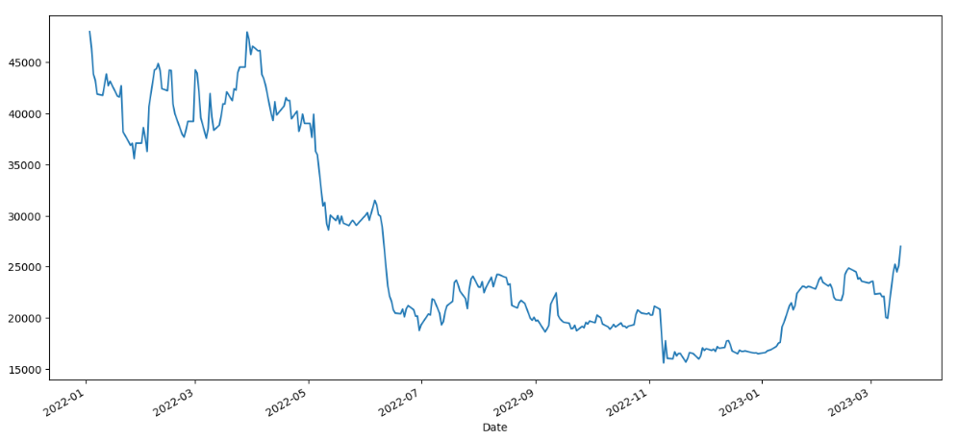

Bitcoin future Historical prices

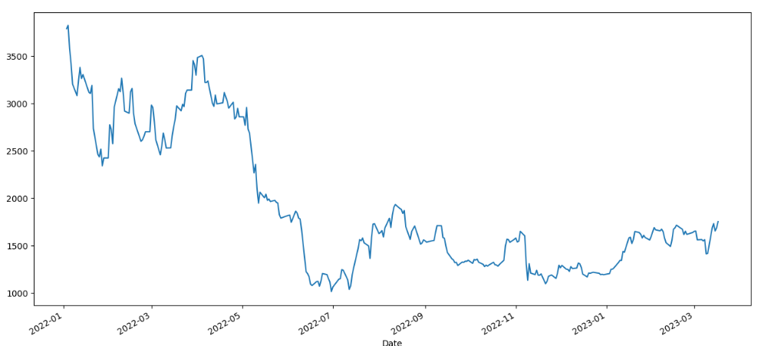

ETF future historical prices

I choose historical price data for two prices from 2022-01-01 to 2023-03-20, and then use three separate methods to predict the spread between the two.Here I use three ways to predict spread separately, namely ARIMA, Kalman-filter and LSTM.

1.ARIMA

ARIMA (Difference Integrated Moving Average Model) is a classical time series forecasting model that is capable of fitting and forecasting non-stationary time series. It transforms a non-stationary time series into a stationary time series by difference and moving average operations, and then fits and predicts it by an autoregressive model. In practice, I use python's statsmodel library to implement it.

2.Kalman-filter

The Kalman filter is a time series model based on statistical principles for inferring and estimating the state of a system. It allows filtering and smoothing of data in the presence of noise and can predict future state values. The Kalman filter is based on dynamic observation of the system state and Bayesian inference of prior information, which improves the accuracy and stability of the state by constantly updating and correcting the prior estimates. Here I use pyKalman library of python to implement it.

3.LSTM

LSTM (Long Short-Term Memory) is a special type of RNN (Recurrent Neural Network) that has more powerful memory capability than standard RNNs. LSTM can learn and remember long-term dependencies in time series and predict the output at future time points. I first perform feature engineering on two time series to generate common technical indicators as input to the neural network model, which are as follows:

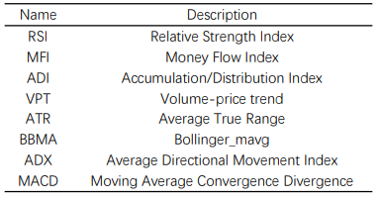

After implement 3 methods, I found LSTM had the best performance, which is much better than ARIMA and Kalman-filter. Below are the predicted value versus ground true.

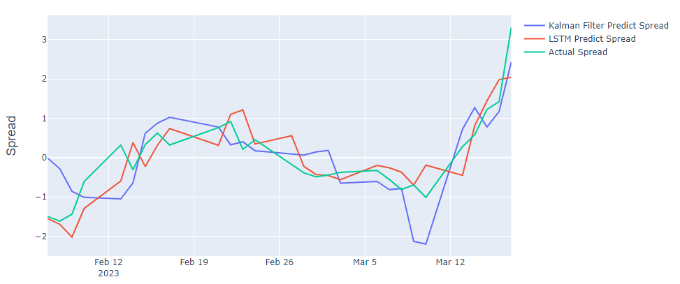

Bitcoin options

• Where are Bitcoin options traded beside the CME?

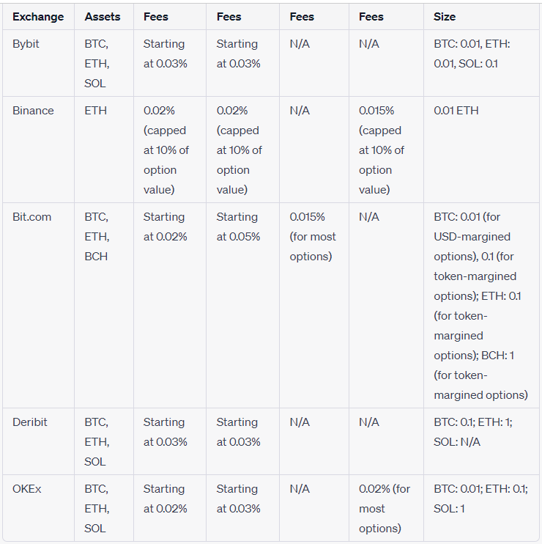

source:<https://milkroad.com/exchanges/options>

In addition to the Chicago Mercantile Exchange (CME)[51], Bitcoin options can be traded on various platforms, with Binance and Deribit being two notable examples. These platforms cater to the unique characteristics of cryptocurrency options trading, such as high implied volatility and smaller contract sizes, to accommodate the highly volatile nature of the cryptocurrency market.

Binance is a popular and well-known cryptocurrency exchange that offers European and American options on cryptocurrencies, including Bitcoin. They provide options with different expiration times, ranging from monthly and weekly options to even shorter expirations such as 1 day or 5 minutes. This flexibility in expiration times allows investors to find suitable trading opportunities in the constantly changing cryptocurrency market. Binance's options are cash-settled, meaning they don't require physical delivery, which further simplifies the trading process for investors.

However, Binance currently does not allow investors to write options themselves to short call or put options. This limitation is likely due to the high potential risk associated with writing options in the volatile cryptocurrency market. For instance, if someone were to write a call option, the price of Bitcoin could theoretically go infinitely high, resulting in potentially unlimited losses for the option writer. The case is slightly better for a short put position, as the price of Bitcoin cannot go below 0, but the writer still needs to pay an amount equal to the strike minus the spot price.

Deribit is another trading platform that specializes in cryptocurrency options and futures trading. Unlike Binance, Deribit allows investors to write options, providing them with detailed contract specifications including initial margin and maintenance margin requirements. This feature offers investors the opportunity to take on different trading strategies and positions in the market. The platform offers Bitcoin options and requires margin reservations for investors taking short positions.

Deribit calculates initial and maintenance margins based on the mark price, which is often derived from the average of the best bid and ask prices. This mark price serves as a benchmark for the options and is used as a reference for investors. The platform also offers detailed information about contract specifications and trading conditions, enabling traders to make informed decisions when participating in the options market.

Both Binance and Deribit have implemented measures to manage the risks associated with the highly volatile cryptocurrency market. For example, Binance offers smaller contract sizes for cryptocurrency options, with the minimum contract size being as low as 0.001 cryptocurrency. For Bitcoin and Litecoin, the maximum contract size is only 20. This helps limit the potential losses that investors might face due to the extreme price swings often seen in the cryptocurrency market.

These platforms, along with CME and other exchanges, provide investors with the opportunity to trade Bitcoin options and potentially profit from accurate predictions of price movements in the volatile cryptocurrency market. By offering a variety of options trading features, including different expiration times and contract sizes, these platforms cater to the needs of diverse investors with varying risk tolerances and trading strategies.

• How is the Fair Value price computed? What models are valid for pricing?

In recent years, various research pieces have focused on the pricing of cryptocurrency options, specifically Bitcoin options. While some researchers have adapted the classical Black-Scholes model by changing the parameters, others argue that the assumptions made by the model do not provide an accurate pricing scheme, especially for the volatile cryptocurrency market. Consequently, researchers have developed new models with different assumptions to price Bitcoin options more accurately. Two such models include the one proposed by Cretarola et al. (2018) and the Stochastic Volatility Model with Correlated Jumps (SVCJ) by Wang et al. (2018).

The Black-Scholes model has faced criticism for its assumptions, particularly the constant risk-free rate and volatility, and the underlying following a Geometric Brownian Motion. These assumptions are considered flawed in both traditional and cryptocurrency markets due to the ever-changing nature of market conditions. The impact of these flaws is especially significant in the cryptocurrency market because of its extreme volatility and large price swings.

To address these shortcomings, Cretarola et al. (2018) proposed a model for pricing European Bitcoin options that includes a stochastic factor, P, which quantifies market sentiment or confidence about Bitcoin. This factor is significant because the price of cryptocurrencies is heavily influenced by market sentiment. For example, Elon Musk's ownership of cryptocurrencies has affected public opinion and confidence in holding crypto assets, leading to price fluctuations. By including the market sentiment parameter in their model, Cretarola et al. aimed to account for such incidents.

Cretarola et al. (2018) presented a bivariate stochastic differential equation in their model:

$$dS_{t}=μ_{S} P_{t-τ} S_{t} dt+ σ_{S} \sqrt{P_{t-τ} } S_{t} dW_{t}, S_{0}=s_{0}∈R,$$

$$dP_{t}=μ_{P}P_{t}dt+ σ_{P}P_{t}dZ_{t}, { P}_{t}=ϕ\left(t\right), t∈\left[-L,0\right],$$

where $ϕ\left(t\right)$ is a deterministic function, $W_{t}$ is a Brownian Motion, and $Z_{t}$ is also a Brownian Motion within the probability space they defined. The parameter P is included throughout the proof, and the integrated confidence process, the integral of the confidence level throughout the time until some T, is given by $X_{t}^{τ}.$ After changes of measure, Cretarola et al. (Risk Neutral Measure and Option Pricing) derived the fair value of the Bitcoin call option to be:

$$C_{t}=\int_{0}^{+∞}{}C^{BS}\left(t,S_{t},x\right)f_{X_{t,T}^{τ}}\left(x\right)dx,$$

where ${ C}^{BS}(t,s,x)≔sN(d_{1}(t,s,x)) - Kexp⁡(-\int_{0}^{t}{}r\left(u\right)du)N(d_{2}(t,s,x))$ with N being the standard normal cumulative distribution. Cretarola et al.'s model accounts for market sentiment and provides an explicit formula for the fair value of a Bitcoin call option.

In contrast to the explicit formula provided by Cretarola et al., many other models, such as the one proposed by Wang et al. (2018), depend on numerical methods to find the fair value, possibly due to the model's complexity. Wang et al.'s Stochastic Volatility Model with Correlated Jumps (SVCJ) is based on the following formulae:

$$dlogS_{t}=µdt+\sqrt{V_{t} } dW_{t}^{(S)}+ Z_{t}^{y}dN_{t}$$

$$dV_{t}=κ\left(θ - V_{t}\right)dt+σ_{V} \sqrt{V_{t}}dW_{t}^{(V)}+Z_{t}^{v}dN_{t}$$

$$Cov\left(dW_{t}^{\left(s\right)}, dW_{t}^{\left(V\right)}\right)=ρdt$$

$$P(dNt = 1) = λdt$$

where $logS_{t}$ refers to the log returns, $\{V_{t}\}$ refers to the volatility process, κ and θ are parameters for the mean reversion rates, and $N_{t}$ is a pure jump process with a constant mean jump-arrival rate λ, and the random jump sizes are $Z_{t}^{y}$ and $Z_{t}^{v}$. The infinitesimal time steps of Brownian Motion from both processes are correlated by the parameter ρ. These sets of assumptions take into account both the price swings of Bitcoin and the nonconstant volatility.

The SVCJ model accounts for sudden price movements in cryptocurrencies due to market sentiment and other factors by including a jump process with a specific frequency. Additionally, the nonconstant volatility, which is a reality in both traditional and digital markets, is addressed by incorporating a stochastic differential equation with a mean-reverting process.

Unlike Cretarola et al.'s model, Wang et al.'s SVCJ model does not provide an explicit formula for the fair value of a Bitcoin option. Instead, they rely on the classical approach of Monte Carlo Simulation to perform estimations. The expected value derived from these simulations is then used as the fair value of the Bitcoin option.

In summary, the pricing of Bitcoin options has been a subject of ongoing research, as traditional models like Black-Scholes fail to account for the unique characteristics of the cryptocurrency market. Researchers have developed alternative models, such as Cretarola et al.'s model with a stochastic factor for market sentiment and Wang et al.'s SVCJ model that accounts for price swings and nonconstant volatility.

Cretarola et al.'s model provides an explicit formula for the fair value of a Bitcoin call option, whereas Wang et al.'s SVCJ model relies on numerical methods like Monte Carlo Simulation to estimate the fair value. Both models attempt to address the shortcomings of the Black-Scholes model by incorporating market sentiment, sudden price movements, and nonconstant volatility in their assumptions.

These alternative models offer a more accurate pricing scheme for Bitcoin options and highlight the importance of continued research in this area. As the cryptocurrency market continues to evolve and mature, further advancements in option pricing models and methodologies will be necessary to ensure accurate and efficient pricing for market participants.

• Describe typical applications but on a separate Excel spreadsheet develop numerical solutions clearly illustrating them. Separately include the Excel spreadsheet with your submission.

Application: Protective Collar Strategy

The protective collar strategy is an effective risk management tool for Bitcoin investors, designed to limit potential losses while still allowing for potential gains. This report outlines the key components of the protective collar strategy, its practical application, and the benefits it offers to investors in the volatile cryptocurrency market.Collar strategy combines a long put option with a short call option to create a "collar" around the current Bitcoin price.

The protective collar strategy consists of the following steps:

1.The investor holds a long position in Bitcoin, which they want to protect against potential price declines.

2.The investor buys a put option on Bitcoin with a strike price below the current market price. This provides downside protection, as the investor can sell their Bitcoin at the strike price if the market price drops significantly.

3.To finance the cost of the put option, the investor sells a call option on Bitcoin with a strike price above the current market price. This allows the investor to collect the premium from selling the call option, which can offset the cost of buying the put option.

4.If the Bitcoin price increases beyond the call option's strike price, the investor's potential gains are capped, as they will be obligated to sell their Bitcoin at the strike price if the option is exercised. However, if the price remains within the "collar" created by the put and call options, the investor can still benefit from any price increases.

The protective collar strategy offers several benefits to Bitcoin investors:

1.Downside Protection: The put option provides a safety net, allowing investors to sell their Bitcoin at a predetermined price if the market price falls significantly. This limits potential losses and helps protect the investor's capital.

2.Potential for Gains: While the short call option caps the investor's potential gains, the strategy still allows for profit if the Bitcoin price remains within the collar. This offers a balance between risk management and the opportunity for returns.

3.Cost Efficiency: By selling a call option to finance the purchase of a put option, the investor can offset the cost of downside protection. This makes the protective collar strategy a cost-effective risk management approach.

Scenario: Let's assume an investor, Alice, currently holds 1 Bitcoin (BTC) valued at $50,000. Alice is concerned about potential price declines but still wants to participate in any potential price increases. She decides to implement a protective collar strategy using options available on the Deribit platform.

1. Alice's Current Position:

1 BTC valued at $50,000

2. Alice buys a put option on Bitcoin with a strike price of $48,000, expiring in one month. The premium for this put option is $1,500.

3.To finance the cost of the put option, Alice sells a call option on Bitcoin with a strike price of $52,000, expiring in one month. The premium for this call option is $1,500.

4.By selling the call option, Alice offsets the cost of buying the put option. The net cost of the protective collar strategy is zero.

Now let's consider three possible outcomes at the end of one month:

Outcome 1: Bitcoin price drops to $45,000

Alice exercises her put option and sells her 1 BTC at the strike price of $48,000, limiting her loss to $2,000 ($50,000 - $48,000).The call option expires worthless, as the price is below the strike price of $54,000.

Outcome 2: Bitcoin price increases to $50,000

The put option expires worthless, as the price is above the strike price of $48,000.The call option is not exercised, as the price is below the strike price of $52,000.Alice's Bitcoin is now worth $50,000.

Outcome 3: Bitcoin price increases to $56,000

The put option expires worthless, as the price is above the strike price of $48,000.The call option is exercised, and Alice is obligated to sell her 1 BTC at the strike price of $52,000.Alice's potential gains becomes 2000.

In all three outcomes, the protective collar strategy effectively limits Alice's downside risk while still allowing her to participate in potential price increases, albeit with a cap on gains. By using this strategy, Alice can navigate the volatile Bitcoin market with greater confidence and security.

Application: Cash-Secured Put Strategy for a Bitcoin Investor

The cryptocurrency market is known for its volatility, and investors often seek ways to acquire digital assets like Bitcoin at a lower price. One such approach is the cash-secured put strategy. This application explores the cash-secured put strategy as a means for Bitcoin investors to potentially purchase Bitcoin at a discounted price while generating income through options premiums.

Cash-Secured Put Strategy:

The cash-secured put strategy involves an investor selling a put option on an underlying asset, such as Bitcoin, while having the cash available to purchase the asset if the option is exercised. The investor collects a premium for selling the put option, which can be used to invest or cover other expenses. This strategy is particularly useful for investors who have a long-term bullish view on the asset but want to enter the market at a more favorable price.

Example Scenario:

Let's assume an investor, Bob, has $40,000 in cash and is interested in buying Bitcoin at a lower price than the current market price of $50,000. Bob decides to implement a cash-secured put strategy using options available on the Deribit platform.

1. Bob's Current Position: $40,000 in cash

2. Bob sells a put option on Bitcoin with a strike price of $45,000, expiring in one month. The premium for this put option is $2,000.By selling the put option, Bob collects the $2,000 premium upfront, which he can use to invest or cover other expenses.

Now let's consider two possible outcomes at the end of one month:

Outcome 1: Bitcoin price drops to $42,000

The put option is exercised, and Bob is obligated to buy 1 BTC at the strike price of $45,000.Since Bob collected a $2,000 premium, his effective purchase price for the Bitcoin is $43,000 ($45,000 - $2,000), which is lower than his desired entry point.Bob now holds 1 BTC valued at $42,000.

Outcome 2: Bitcoin price increases to $52,000

The put option expires worthless, as the price is above the strike price of $45,000.Bob keeps the $2,000 premium, increasing his cash position to $42,000.In this case, Bob doesn't acquire any Bitcoin, but he still profits from the premium he collected.

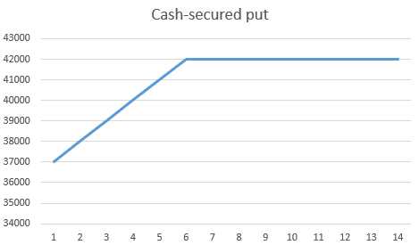

Conclusion:

The cash-secured put strategy is a useful approach for Bitcoin investors seeking to potentially purchase Bitcoin at a lower price than the current market price, while also generating income from options premiums. By employing this strategy, investors can benefit from the premium collected, which can be reinvested or used for other purposes. It is important to note that this strategy exposes the investor to the risk of potentially missing out on price appreciation if the option is not exercised. However, the cash-secured put strategy offers a balanced approach for long-term investors who have a bullish outlook on Bitcoin but want to enter the market at a more favorable price.

Bitcoin OTC Contracts and Financial Instruments

• List and describe examples you find of OTC CD contracts, smart contracts, Crypto bonds, Crypto loans and other Crypto structures with market transactions in the past 4 years. Provide specific sources for all examples

The Over-the-Counter (OTC) market for cryptocurrencies has evolved over time, offering deeper liquidity, greater privacy, and personalized services to high-net-worth individuals, institutions, hedge funds, and others who find trading standardized contracts inconvenient. The development of smart contracts, crypto bonds, and crypto loans has further shaped the landscape of the crypto market, with innovations continuing to emerge.

In August 2018, the World Bank Group launched bond-i, the world's first blockchain-based bond instrument. The two-year bond raised $110 million, marking the first time investors supported the World Bank's development activities through a transaction fully managed using blockchain technology (World Bank, 2018)[48]. This milestone illustrated the growing impact of blockchain technology on traditional financial products and paved the way for future developments in the crypto market.

As smart contracts gained traction, their integration into various industries, including real estate, corporate ownership, and creative debt instruments, began to accelerate. Ethereum, for instance, offers programming languages for users to develop their smart contracts, which automatically facilitate transactions between parties when predetermined conditions are met. The growing efficiency and versatility of smart contracts have prompted their widespread adoption across different sectors.

In December 2021, the International Swaps and Derivatives Association (ISDA) released the "Contractual Standards for Digital Assets Derivatives" to provide guidelines for the burgeoning crypto market, including OTC derivatives. The document focuses on five main areas: categorizing digital assets, defining potential disruption events, valuing digital assets, examining the interaction between new guidelines and existing documentation, and addressing collateral-related issues.

Crypto loans, another example of digital debt instruments, emerged as a popular financial product. These loans fall into two categories: custodial, which require collateral, and non-custodial, which do not require collateral but charge higher interest rates. Binance, a leading cryptocurrency exchange, offers custodial loans with a range of available collateral options and varying loan terms. Borrowers must carefully consider which cryptocurrencies to use as collateral, as the interactions between different digital assets can affect their trading strategies.

Lastly, forward contracts with cryptocurrencies as underlying assets have gained traction. Crypto forward contracts are agreements between two parties to buy or sell a fixed amount of a crypto asset based on predetermined terms, with payment and product delivery settled on an agreed-upon date. These contracts allow for more personalized terms than futures contracts, but they also entail higher counterparty risk due to the absence of a clearinghouse.

Crypto swaps, another emerging derivative product, enable parties to hedge against currency risk and speculate on price movements. Soylemez (2019) introduced the concept of atomic swaps, which facilitate the exchange of cryptocurrencies from different blockchains without third-party involvement, ensuring secure transfers through Hashed Timelock Contracts.

In March 2023, the London Stock Exchange, through its subsidiaries LCH Limited and LCH S.A., announced its plans to seek regulatory approval for offering clearing services for cash-settled Bitcoin index futures and options contracts traded on GFO-X. According to the announcement, the new offering will be provided under LCH DigitalAssetClear, a recently established clearing service.GFO-X is a UK-based derivatives trading platform regulated by the Financial Conduct Authority (FCA) and LCH S.A. Catering primarily to institutional investors, GFO-X works closely with all market participants to satisfy their needs, including digital asset derivatives trading and clearing in secure and regulated market conditions.Developed in collaboration with LCH S.A., GFO-X's LCH DigitalAssetClear aims to expand its services to include cash-settled Bitcoin index futures and options contracts. The offering is expected to be based on the GFO-X/Coin Metrics Bitcoin Reference Rate (GCBRR), which refers to a BMR-compliant reference rate for the US dollar value of Bitcoin.Institutions are anticipated to benefit from this innovative service, as it enables them to trade futures and options on the Bitcoin reference index directly. LCH, which follows an open-access model and partners with multiple execution venues, is committed to maintaining high standards in risk management while providing a broad range of options and efficiencies to the market.Operating through its UK and France clearing houses, and with offices in the United States and Asia Pacific, LCH offers a diverse array of clearing services. These services cover OTC and listed rates, CDS and FX, fixed income, commodities, cash equities, and equity derivatives. The introduction of LCH DigitalAssetClear signals further expansion into the digital asset market, reflecting the growing interest and demand for crypto-related financial products.

In conclusion, the crypto OTC market, smart contracts, and various digital debt instruments have transformed the financial landscape over the years, with continuous developments and innovations driving the growth of the crypto market. As technology and regulations continue to evolve, the impact of these digital assets on the global economy is expected to expand further.

• Are there special terms or market mechanics to be aware of for Crypto forwards and swaps?

Yes, like atomic swaps.Then what is an atomic swap?

Much like how we’d never put diesel gasoline in a conventional engine, attempts to send crypto to an incompatible blockchain can result in disaster, including lost funds. For example, we can’t send Bitcoin to an Ethereum address, and vice versa. To safely execute a trade across blockchains requires an atomic swap, a peer-to-peer method of exchanging cryptocurrencies between two different blockchains without the need for any third-party involvement.

Atomic swaps include built-in functions requiring both participants to fulfill certain predetermined steps before a transaction can be finalized. Atomic swaps utilize something called Hashed Timelock Contracts (HTLC) which impose certain trading conditions and a time constraint mandating they also must be completed within a set time.

A simplified version of how this works is as follows. Alice and Bob have agreed to exchange her 25 ETH for his 1.5 BTC. First, Bob must create a smart contract address to which he sends his BTC. The contract will auto-generate a unique cryptographic key that’s needed to access the funds. Based on this key, the smart contract also generates an encrypted (or “hashed”) version of the key, which Bob then sends to Alice.Using this hashed key, Alice can verify that Bob has indeed deposited his funds. However there’s no possible way for her to withdraw the funds until the conditions of the swap have all been met. Alice must then generate her own contract address based on the hashed key where she can send her ETH. Once Bob claims the funds Alice has locked up in the smart contract, the password Alice needs to access Bob’s deposit is automatically revealed.

Central Bank Digital Currencies (CBDCs):

What are CBDCs? How do they work?

Central bank digital currencies (CBDCs) are digital currencies issued by a country's central bank, which have a fixed value equivalent to the country's fiat currency[53]. They share similarities with cryptocurrencies but are distinct in their dependence on the central bank's value backing. CBDCs are currently under development in numerous countries, and some have already been implemented. As the transition to digital currencies gains momentum, it is crucial to comprehend their implications for society.

Issues CBDCs Address and Create

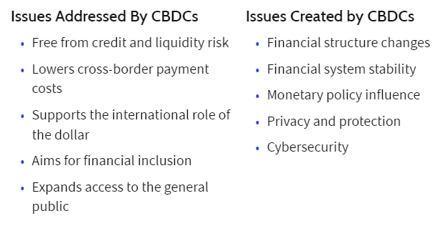

source：https://www.investopedia.com/

How CBDCs work:

In the U.S. and several other nations, a considerable proportion of individuals lack access to financial services. In the U.S. alone, 5% of adults did not have a bank account in 2020, and 13% of those with bank accounts used expensive alternative services such as check-cashing facilities, payday loans, and money orders[54].

The primary objective of CBDCs is to offer individuals and businesses privacy, convenience, accessibility, transferability, and financial security. CBDCs could also reduce the maintenance costs of a complex financial system, lower cross-border transaction expenses, and provide cheaper alternatives to those currently using alternative money-transfer methods[55].

Moreover, CBDCs would mitigate the risks linked with current forms of digital currencies, such as cryptocurrencies, which are highly volatile and can cause financial stress in households and jeopardize the stability of an economy[55]. Backed by a government and managed by a central bank, CBDCs would provide households, consumers, and businesses a reliable method of exchanging digital currency.

There are two types of CBDCs: wholesale and retail. Wholesale CBDCs function similarly to holding reserves in a central bank, where financial institutions use them for interbank transfers and deposit funds. Central banks use monetary policy tools to influence lending and set interest rates.

Retail CBDCs are government-backed digital currencies designed for consumer and business use, eliminating intermediary risk. There are two types of retail CBDCs: token-based and account-based. Token-based CBDCs allow for anonymous transactions using private keys or public keys, while account-based CBDCs require digital identification to access an account.

CBDCs versus Cryptocurrency

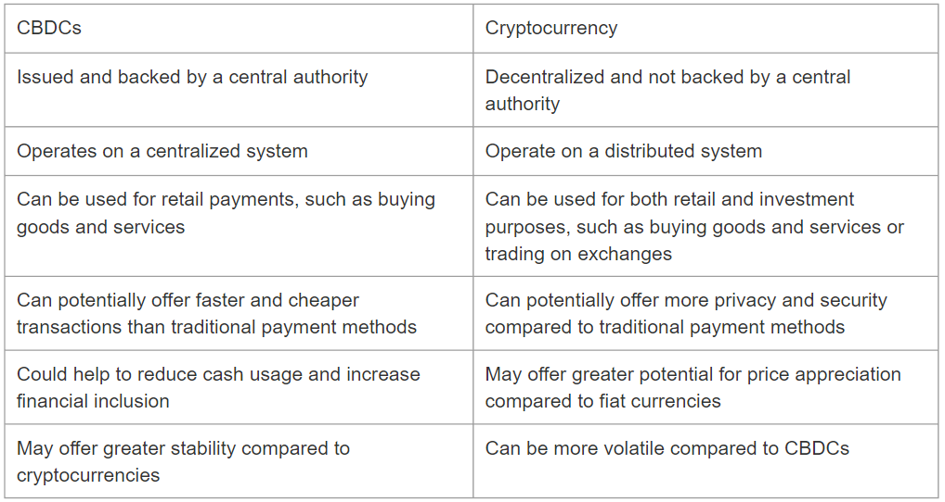

CBDCs (Central Bank Digital Currencies) and cryptocurrencies are both digital currencies, but they differ in several key ways[49].

1. Backing: CBDCs are backed by a central bank, while cryptocurrencies are not. This means that CBDCs have the full faith and credit of the government behind them, while cryptocurrencies rely solely on the trust of their users.
2. Value: The value of CBDCs is fixed to the value of the country's fiat currency, while the value of cryptocurrencies is determined by market forces and can be highly volatile.
3. Regulation: CBDCs are regulated by the government and subject to the same laws and regulations as traditional currency, while cryptocurrencies operate largely outside of government regulation.
4. Privacy: CBDCs can be designed to provide privacy features, but this is not always the case. Cryptocurrencies, on the other hand, are often designed to provide anonymous transactions.
5. Accessibility: CBDCs are designed to be accessible to everyone, including those who do not have access to traditional banking services. Cryptocurrencies, on the other hand, require a certain level of technical knowledge and access to the internet.
6. Functionality: CBDCs can be used for a variety of transactions, including retail purchases and cross-border payments. Cryptocurrencies, on the other hand, are primarily used for speculative trading and investment.

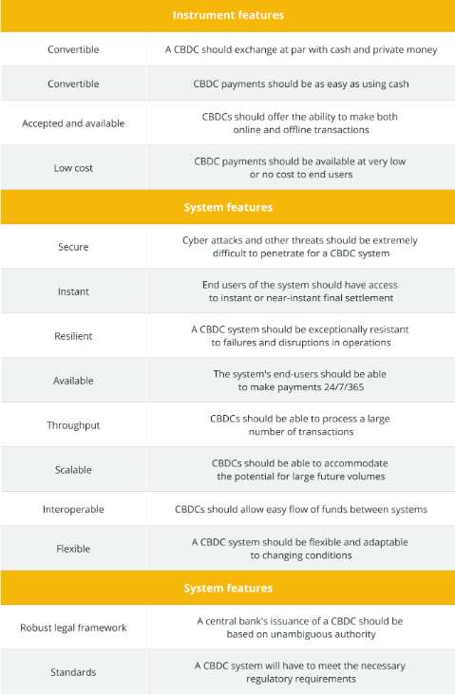

source:https://cointelegraph.com/

What countries are researching this topic?

Numerous countries are researching and developing CBDCs. Some countries have already implemented them on a trial basis, while others are still in the exploratory phase.

Some of the countries that have publicly announced research and development of CBDCs include:China, Sweden, The Bahamas,Japan, South Korea, Russia, Canada, The United States, The United Kingdom, The European Union,Singapore, Thailand, The United Arab Emirates, Saudi Arabia,Brazil, Australia

Do any CBDCs exist currently?

Yes, CBDCs exist currently in China. The Chinese government has been testing the digital RMB in certain regions, while the digital RMB feature is also live on Alipay

The Central Bank of China set up a special research group for the issuance of a legal digital currency in 2014, and a series of research reports on digital currencies were issued in 2015. The prototype law an prototype bill w completed two rounds of revisions, in 2017 the Central Bank Digital Currency Research Institute was officially launched, a blockchain-based digital note trading platform was established for testing, in 2018, the digital note trading platform s experimental production system was successfully launched and operated, in 2019, the Central Bank Payment and Settlement Company stated that "the Central Bank digital currency is on the verge of emergence and will adopt a two-tier operation system".In 2020, China's central bank has almost completed the design of the digital RMB and is testing it in several major cities and Olympic venues. 2021 will see the rollout of the digital RMB by China's state-owned banks and the testing of the digital RMB by Alipay. 2022 will also see the digital RMB cover more than 400,000 Winter Olympics scenes in Beijing.

Event Contracts on Bitcoin:

Describe these newest of Crypto derivatives listed on CMEGroup.com.

Bitcoin Event Contracts have emerged as one of the latest additions to the suite of regulated crypto contracts offered by the Chicago Mercantile Exchange (CME). These contracts provide a simplified way for individuals and institutions to access Bitcoin exposure at its most liquid and institutionally trusted price - the regulated CME CF Bitcoin Reference Rate (BRR)[57].

The demand for regulated exposure to Bitcoin has been growing in recent years, as more investors seek to invest in this digital asset. However, investing in Bitcoin comes with risks, including volatility, security concerns, and uncertainty surrounding regulatory environments. This is where Bitcoin Event Contracts come into play, providing a simpler, more accessible, and more secure way to access Bitcoin exposure[57].

In essence, Bitcoin Event Contracts are daily expiring, limited-risk, cash-settled, European-style options on Bitcoin futures. These contracts are designed to provide straightforward, short-term exposure to Bitcoin, making them particularly attractive to retail investors who want to invest in Bitcoin but do not necessarily have the knowledge or resources to trade Bitcoin futures or other complex derivatives.

The primary difference between Bitcoin Event Contracts and other CME Bitcoin products is their retail interface to institutionally trusted Bitcoin exposure. Like all CME Bitcoin products, Bitcoin Event Contracts settle to the BRR, assuring the highest possible reliability, accuracy, and resistance to manipulation. They are fully fledged options and are subject to Position Limits and Accountability rules.

In contrast to traditional options on futures, Bitcoin Event Contracts settle with reference to a daily settlement price of BRR, and do not exercise into underlying futures positions. If an Event Contract expires “in the money,” the short position holder pays the long position holder $20, and the maximum risk on a long position is known upfront. Event Contracts have premium-style margining, meaning a long position in an Event Contract will pay the full premium for each contract.

The fixed payout structure of Bitcoin Event Contracts means that the maximum risk on a long position is known upfront. Meanwhile, if an Event Contract expires "in the money," the short position holder pays the long position holder $20, and the maximum per-contract risk for a short position is $20, minus the premium received for selling the option.

Bitcoin Event Contracts provide investors with a straightforward and accessible way to gain exposure to Bitcoin while managing their risk. They are designed to provide investors with access to the highest quality and most liquid Bitcoin market possible, with the backing of a regulated exchange and a benchmark that is recognized and trusted by institutions worldwide.

One of the key benefits of Bitcoin Event Contracts is their simplicity. Investors do not need to have a deep understanding of Bitcoin or the derivatives markets to trade these contracts. Bitcoin Event Contracts are designed to be accessible to all investors, including those who are new to Bitcoin and derivatives trading. This is an important consideration, as the complexity of Bitcoin derivatives markets can be a barrier to entry for many retail investors.

The availability of Bitcoin Event Contracts on a regulated exchange also provides investors with additional security and protection. Regulated exchanges are required to follow strict rules and regulations to ensure that they operate fairly and transparently. Investors can be assured that the trading of Bitcoin Event Contracts takes place on a level playing field, and that their investments are protected by the regulatory framework of the exchange.

Summary：

The creation of blockchain has cultivated environments in which digital coins can be traded in efficient, transparent, and secure ways. Such an inventive financial ecosystem has attracted investors to trust the technology behind and pay fiat currencies to exchange for digital currencies as a way of supporting and investing. With the value people endow with, the booming cryptocurrency market has led to an influx of crypto derivatives to provide hedging on their exposures. People has brought traditional crypto derivatives to the realm of cryptocurrencies in form of crypto futures and forwards, crypto options. There are also crypto derivatives solely applicable in the crypto market such as perpetual futures where new terminologies and valuation schemes are involved to deal with the never-settled futures contracts. The futures market has the traded volume and existing research pieces have been able to provide detailed valuations for futures. The no-arbitrage argument is stilled applied to find fair values while some researchers have incorporated inputs such as mining costs and electricity costs as part of the pricing equations since the transaction is virtual. The option market is currently much smaller and option pricing is more complicated because of the more volatile behaviors for the underlying. Black-Scholes model doesn’t tend to provide satisfying valuation because it fails to account for the change volatility and large price jumps. While there are theoretical pieces to explicitly derive the price, many pieces applied numerical methods and simulations to approximate the fair value. The predictability of machine learning models has prompted some researchers to directly train existing prices without theoretical derivations behind. Different valuation schemes can be found for crypto derivatives as people put various assumptions into the crypto market. In addition, crypto bonds, loans, smart contracts that operate on blockchain are also at their nascent stage. Related research pieces are rare since people are still exploring the features of these instruments with institutions gradually bringing these instruments to the public. Similarly, the swap market is at its beginning stage with people publishing pieces on how to realize exchanges of cryptocurrencies from different blockchains. Regulations are also constantly updating to provide guidelines for crypto derivatives including OTC. Overall, crypto derivative instruments can expect more explorations and further in-depth studies to fill the knowledge gap. As blockchain has brought to investors a system that works differently, many creative instruments can certainly be expected to be witnessed in future time.

**References**

[1] Nian, Lam & Chuen, David. (2015). Introduction to Bitcoin. 10.1016/B978-0-12-802117-0.00001-1.

[2] Dannen, C. (2017). *Introducing Ethereum and solidity* (Vol. 1, pp. 159-160). Berkeley: Apress.

[3] A. H. Mohammed, A. A. Abdulateef and I. A. Abdulateef, "Hyperledger, Ethereum and Blockchain Technology: A Short Overview," 2021 3rd International Congress on Human-Computer Interaction, Optimization and Robotic Applications (HORA), Ankara, Turkey, 2021, pp. 1-6, doi: 10.1109/HORA52670.2021.9461294.

[4] Audil Rashid, Walid Bakry, Somar Al-Mohamad. (2023) Are cryptocurrencies a future safe haven for investors? The case of Bitcoin. Economic Research-Ekonomska Istraživanja 36:2.

[5] J. Bohr and M. Bashir, "Who Uses Bitcoin? An exploration of the Bitcoin community," 2014 Twelfth Annual International Conference on Privacy, Security and Trust, Toronto, ON, Canada, 2014, pp. 94-101, doi: 10.1109/PST.2014.6890928.

[6] Amola Bhatt, Mayank Joshipura, Nehal Joshipura. (2022) Decoding the trinity of Fintech, digitalization and financial services: An integrated bibliometric analysis and thematic literature review approach. Cogent Economics & Finance 10:1.

[7] Schmidt R, Möhring M, Glück D, et al. Benefits from using Bitcoin: empirical evidence from a European country[J]. International Journal of Service Science, Management, Engineering, and Technology (IJSSMET), 2016, 7(4): 48-62.

[8] Buterin V. Ethereum: platform review[J]. Opportunities and challenges for private and consortium blockchains, 2016, 45.

[9] Gandal N, Hamrick J T, Moore T, et al. The rise and fall of cryptocurrency coins and tokens[J]. Decisions in Economics and Finance, 2021, 44(2): 981-1014.

[10] Arslanian H. Crypto exchanges[M]//The Book of Crypto: The Complete Guide to Understanding Bitcoin, Cryptocurrencies and Digital Assets. Cham: Springer International Publishing, 2022: 335-350.

[11] Suratkar S, Shirole M, Bhirud S. Cryptocurrency wallet: A review[C]//2020 4th international conference on computer, communication and signal processing (ICCCSP). IEEE, 2020: 1-7.

[12] Daskalakis N, Georgitseas P. An introduction to cryptocurrencies: the crypto market ecosystem[M]. Routledge, 2020.

[13] Ahuja M P. Cryptocurrency: A New Millennium Currency (Problem and Prospects in India)[J].

[14] Oxford Analytica. US crypto regulation tightens amid federal gridlock[J]. Emerald Expert Briefings, 2023 (oxan-db).

[15] He W. Is cryptocurrency personal property under Australian law? It depends[J]. Common Law World Review, 2023: 14737795231166969.

[16] Kaur G, Habibi Lashkari A, Sharafaldin I, et al. Introduction to Smart Contracts and DeFi[M]//Understanding Cybersecurity Management in Decentralized Finance: Challenges, Strategies, and Trends. Cham: Springer International Publishing, 2023: 29-56.

[17] Christina K, Kesavamoorthy R. Evolution of Blockchain and Smart Contracts: A State of the Art Review[C]//2023 International Conference on Intelligent Systems for Communication, IoT and Security (ICISCoIS). IEEE, 2023: 235-240.

[18] Ferko A, Moin A, Onur E, et al. Who trades bitcoin futures and why?[J]. Global Finance Journal, 2023, 55: 100778.

[19] Soska K, Dong J D, Khodaverdian A, et al. Towards understanding cryptocurrency derivatives: a case study of bitmex[C]//Proceedings of the Web Conference 2021. 2021: 45-57.

[20] Day M Y, Cheng Y, Huang P, et al. The profitability of Bollinger Bands trading bitcoin futures[J]. Applied Economics Letters, 2022: 1-7.

[21] De Blasis R, Webb A. Arbitrage, contract design, and market structure in Bitcoin futures markets[J]. Journal of Futures Markets, 2022, 42(3): 492-524.

[22] Zou J. Exploring Arbitrage Opportunities between the BTC Spot and Futures Market based on Funding Rates Mechanism[C]//2022 7th International Conference on Financial Innovation and Economic Development (ICFIED 2022). Atlantis Press, 2022: 1923-1928.

[23] Lin S, Wang M, Cheng Z, et al. Risk Management of Fuel Hedging Strategy Based on CVaR and Markov Switching GARCH in Airline Company[J]. Sustainability, 2022, 14(22): 15264.

[24] Alexander C, Deng J, Zou B. Hedging with automatic liquidation and leverage selection on bitcoin futures[J]. European Journal of Operational Research, 2023, 306(1): 478-493.

[25] Blau B M, Whitby R J. The introduction of bitcoin futures: an examination of volatility and potential spillover effects[J]. Economics Bulletin, 2019, 39(2): 1.

[26] Corbet, Shaen, et al. "Exploring the dynamic relationships between cryptocurrencies and other financial assets." *Economics Letters* 165 (2018): 28-34.

[27] Söylemez Y. Cryptocurrency derivatives: The case of Bitcoin[J]. Blockchain Economics and Financial Market Innovation: Financial Innovations in the Digital Age, 2019: 515-530.

[28] Cretarola A, Figà-Talamanca G, Patacca M. Market attention and Bitcoin price modeling: Theory, estimation and option pricing[J]. Decisions in Economics and Finance, 2020, 43: 187-228.

[29] Hou A J, Wang W, Chen C Y H, et al. Pricing cryptocurrency options[J]. Journal of Financial Econometrics, 2020, 18(2): 250-279.

[30] Hale G, Krishnamurthy A, Kudlyak M, et al. How futures trading changed bitcoin prices[J]. FRBSF Economic Letter, 2018, 12: 1-5.

[31] Augustin P, Rubtsov A, Shin D. The impact of derivatives on cash markets: Evidence from the introduction of bitcoin futures contracts[J]. Available at SSRN, 2020.

[32] Moffett T A. CFTC & SEC: The Wild West of Cryptocurrency Regulation[J]. University of Richmond Law Review, 2023, 57(2): 713-762.

[33] Radanliev P. Review and comparison of US, EU, and UK regulations on cyber risk/security of the current Blockchain Technologies-viewpoint from 2023[J]. EU, and UK Regulations on Cyber Risk/Security of the Current Blockchain Technologies-Viewpoint from, 2023.

[34] Riley J. The current status of cryptocurrency regulation in China and its effect around the world[J]. China and WTO Review, 2021, 7(1): 135-152.

[35] Xie R. Why China had to ban cryptocurrency but the US did not: a comparative analysis of regulations on crypto-markets between the US and China[J]. Wash. U. Global Stud. L. Rev., 2019, 18: 457.

[36] Allen F, Gu X, Jagtiani J. Fintech, cryptocurrencies, and CBDC: Financial structural transformation in China[J]. Journal of International Money and Finance, 2022, 124: 102625.

[37] Shen W, Hou L. China's central bank digital currency and its impacts on monetary policy and payment competition: Game changer or regulatory toolkit?[J]. Computer Law & Security Review, 2021, 41: 105577.

[38] Rousseau C. Cryptocurrency Offerings in Canada: Why and How We Should Modernize the Securities Law Framework[J]. Banking & Finance Law Review, 2019, 35(1): 63-92.

[39] Sin J C C. Global Cryptocurrency Benchmarking Study and Market Analysis[J].

[40] Clements R. Regulating Fintech in Canada and the United States: Comparison, challenges and opportunities[J]. The Routledge Handbook of FinTech, 2021.

[41] Sulimierska M, Sikorska A. The Cryptoassets Market in the United Kingdom: Regulatory and Legal Challenges[M]//The Fintech Disruption: How Financial Innovation Is Transforming the Banking Industry. Cham: Springer International Publishing, 2023: 215-242.

[42] Gu Y. The comparative study of Bitcoin market in the UK and China[J].

[43] Pravdiuk M. International experience of cryptocurrency regulation[J]. Norwegian Journal of Development of the International Science, 2021 (53-2): 31-37.

[44] Sebastião H, Godinho P. Bitcoin futures: An effective tool for hedging cryptocurrencies[J]. Finance Research Letters, 2020, 33: 101230.

[45] Aysan A F, Sadriu B, Topuz H. Blockchain futures in cryptocurrencies, trade and finance: a preliminary assessment[J]. Buletin Ekonomi Moneter Dan Perbankan, 2020, 23(4): 525-542.

[46] Lian, Y., Cheng, C., Lin, S., & Lin, J. (2019). A cost of carry-based framework for the Bitcoin

Futures Price modeling. Journal of Mathematical Finance, 09(01), 42-53. doi:10.4236/jmf.2019.91004

[47] Binance. (2020, June 28). Contract information of some crypto options on Binance [Image].

Retrieved from <https://www.binance.com/en/support/faq/360041877431>

[48] World Bank Group. (2018, September 12). World Bank prices first global blockchain bond,

raising A$110 million. Retrieved April 18, 2022, from https://www.worldbank.org/en/news/press-release/2018/08/23/world-bank-prices-first-global-blockchain-bond-raising-a110-million

[49] Allen F, Gu X, Jagtiani J. Fintech, cryptocurrencies, and CBDC: Financial structural transformation in China[J]. Journal of International Money and Finance, 2022, 124: 102625.

[50] CME Group. (n.d.). Bitcoin futures - contract specs [Table]. Retrieved from

https://www.cmegroup.com/trading/cryptocurrency-indices/cme-options-bitcoin-futures-frequently-asked-questions.html

[51] CME Group. (n.d.). Contract specs -- option on bitcoin futures [Table]. Retrieved from

https://www.cmegroup.com/trading/cryptocurrency-indices/cme-options-bitcoin-futures-frequently-asked-questions.html

[52] CME Group. (n.d.). Contract specs – Ethereum futures [Table]. Retrieved from

<https://www.cmegroup.com/markets/cryptocurrencies/ether/ether.contractSpecs.html>

[53] Ward O, Rochemont S. Understanding central bank digital currencies (CBDC)[J]. Institute and Faculty of Actuaries, 2019: 1-52.

[54] Infante S, Kim K, Orlik A, et al. The Macroeconomic Implications of CBDC: A Review of the Literature[J]. 2022.

[55]Bank of Canada Technology Approach for a CBDC. Retrieved from <https://www.bankofcanada.ca/2020/02/staff-analytical-note-2020-6/>

[56] CME Group. (n.d.). Contract specs – CME Group Announces First Day of Trading of Event Contracts on Bitcoin Futures [Table]. Retrieved from https://www.cmegroup.com/media-room/press-releases/2023/3/13/cme_group_announcesfirstdayoftradingofeventcontractsonbitcoinfut.html

[57] CME Group. (n.d.). Contract specs – CME Event Contracts on Bitcoin Futures [Table]. Retrieved from https://www.cmegroup.com/activetrader/event-contracts.html

**Appendix**

*Contract specs – bitcoin futures*

By CME Group

Note. Adapted from https://www.cmegroup.com/trading/cryptocurrency-indices/cme-options-bitcoin-futures-frequently-asked-questions.html. Copyright (n.d) by CME Group.

Contract specs – Ethereum futures

By CME Group

Note. Adapted from https://www.cmegroup.com/markets/cryptocurrencies/ether/ether.contractSpecs.html. Copyright (n.d) by CME Group

Contract specs – option on bitcoin futures

By CME Group

Note. Adapted from https://www.cmegroup.com/trading/cryptocurrency-indices/cme-options-bitcoin-futures-frequently-asked-questions.html. Copyright (n.d) by CME Group.